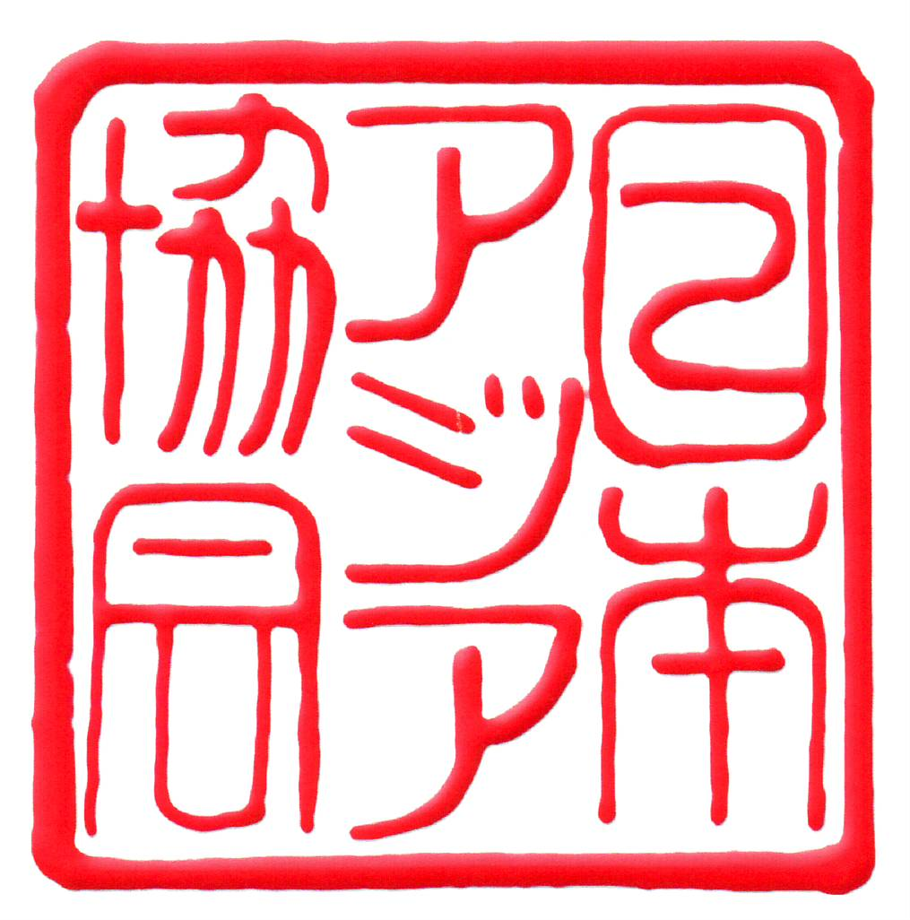
The Asiatic Society of Japan
Honorary Patron: H.I.H. Princess Takamado
Cooperative Science and Research Body of the Science Council of Japan
c/o Tokyo Health Care University,
2-5-1 Higashigaoka, Meguro-ku, Tokyo 152-8558
Tel/Fax: 03-3795-2371
E-mail: info@asjapan.org
Website: http://www.asjapan.org

Bulletin No. 2 March 2017

Spring Greetings to ASJ members:

We sincerely apologize for failing to send out bulletins for February and March but nonetheless hope to see many of you at the meetings described below:

March Meeting: Monday, March 27th at 6:30 p.m.
Speaker: Dr. Peter O’Connor
Subject: “The Japan Times, the Nippon Times and the Cuckoo Press of
Greater East Asia, 1940-1945”
Venue: Shibuya Kyōiku Gakuen, 1-21-18 Shibuya, Shibuya-ku, Tokyo 150-0002

Abstract: This talk is an attempt to frame the wartime history of the Japan Times in the context of the Greater East Asia Co-Prosperity Sphere and of the Pacific War in general.

During the astonishing run of victories following the attack on Pearl Harbor, Japanese media entrepreneurs, journalists and publicists worked in the rear of their armed forces in Shanghai, Hong Kong, Penang, Singapore, Manila, and the former French and Dutch colonies, to realign news production and distribution flows to information hubs whose location reflected the new mastery of East and South-East Asia.

In this process some English-language and vernacular newspapers were closed down entirely. Others were allowed to continue, their credibility suborned to an editorial line supporting the conqueror’s agenda. Still others were renamed and restaffed and their printing plant taken over by ‘cuckoo’ newspapers, a robust species that thrived in the nutrient medium of war.

At the heart of Japan’s project, the Japan Times, renamed the Nippon Times, became the flagship organ for the propagation of the ideals of the Greater East Asia Co-Prosperity Sphere. As the presiding organ at the Greater East Asia Newspaper Conference held in Tokyo in November 1943, the Nippon Times offered a reliable template for editorials throughout the Sphere. There was, however, an elephant in the Nippon Times news room, and it spoke English.

Dr. Peter O’Connor has been lecturing and writing on the transnational media history of East and South-East Asia for some time. In April 1997 he addressed a joint meeting of the Society and the Japan Times held to mark the Centenary of this considerable newspaper. He holds a history doctorate from SOAS, University of London and teaches at Musashino and other universities in Tokyo.

====================================================================================

April Meeting: Monday, April 17th at 6:30 p.m.
Speaker: Katsura Sunshine
Subject: “Rakugo a Broadway Hit? Why not?!”
Venue: Tokiwamatsu Hall, Kokugakuin University, 4-10-28 Higashi,
Shibuya-ku, Tokyo 150-8440
Access: Tokyo Metropolitan Bus: take a “Gaku 03 (学03)” Nisseki Iryo Center
bound bus from Shibuya station east exit bus terminal 54 bus stop,
get off at “Kokugakuin University Mae”.

As we need to know the approximate number of attendees, please register by email or fax (03-3795-2371) for the event by Sunday, April 2nd. This time there is no need to present a confirmation letter, and so none will be sent.

An extra attraction is the opportunity to visit, free of charge, the Kokugakuin University Museum, located in the same building (Tokiwamatsu Hall). There is also a university cafe next to Tokiwamatsu Hall. Please note that it closes at 6:00 p.m.

